Name: Varlene

Surname: Sibanda

Student Number: ST10276007

Module: SOEN6222 – User Interface Prototype and Self-Evaluation

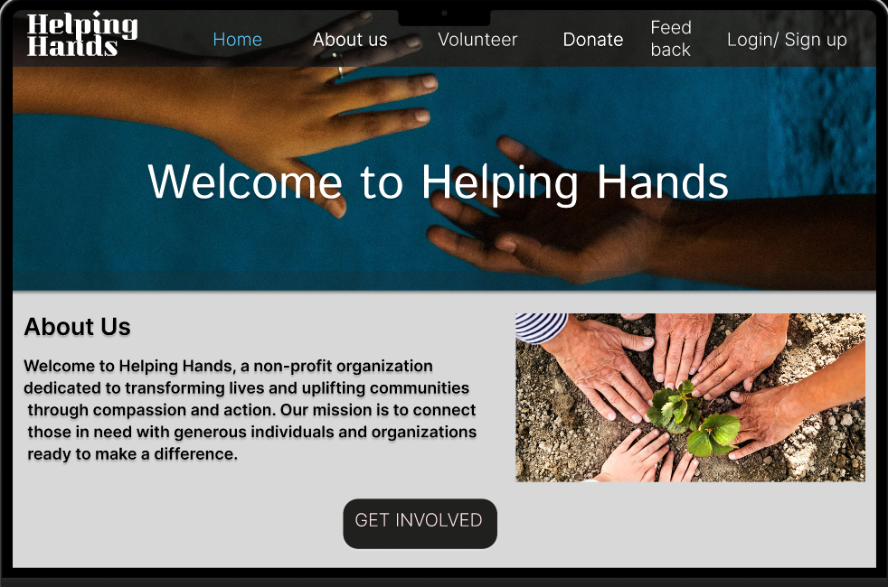

### 1. Home Page

User: General users (volunteers, donors, and visitors)

The Home Page acts as the primary entry point to the Helping Hands platform, welcoming visitors and guiding them toward their desired actions. It provides an overview of the organization’s mission, and goals, ensuring users understand the impact Helping Hands is making in their communities. Key features include navigational links to sections like the Volunteer Dashboard, Donation Dashboard, and Feedback Dashboard, along with prominent calls-to-action for registering or logging into the system, and a getting involved by volunteering or becoming a donor.

Visitors can quickly explore current initiatives, such as volunteer opportunities or donation drives, by navigating from the home page. The design ensures accessibility for all user types, with clear paths to learn more about events and apply for roles or make contributions. This page is crucial in drawing users into the ecosystem, ensuring both first-time visitors and returning users can seamlessly navigate to their desired functionality.

Requirements Met:

* Welcomes users with an intuitive interface and clear organizational details.
* Directs users to actionable links for registration, volunteering, donating, or leaving feedback.

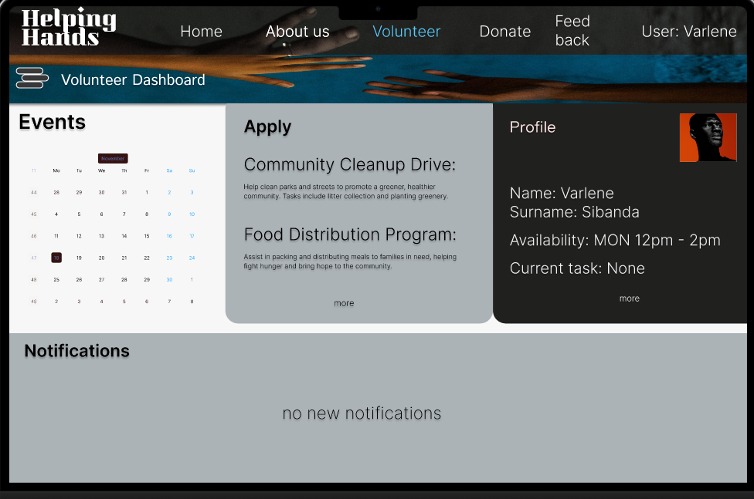

### 2. Volunteer Dashboard

User: Volunteers

The Volunteer Dashboard is designed for registered volunteers to manage their profiles and explore opportunities. From here, volunteers can view upcoming events, sign up for roles, and track their logged hours. The dashboard provides a personalized experience by displaying the user’s name, their engagement history, and a calendar view of events they have signed up for.

In addition, the dashboard offers links to relevant resources, such as training materials or guides to assist volunteers in preparing for their assigned roles. It allows volunteers to update personal information, ensuring their details remain accurate. Notifications and reminders are prominently displayed, helping users stay informed about event updates or deadlines for applications.

This page prioritizes functionality and user-friendliness, making it easy for volunteers to engage with Helping Hands effectively. By providing a dedicated space to track their activities, the Volunteer Dashboard encourages ongoing participation.

Requirements Met:

* Provides volunteers with a personalized space to manage their profiles and event participation.
* Displays information about upcoming opportunities and allows seamless application to events.

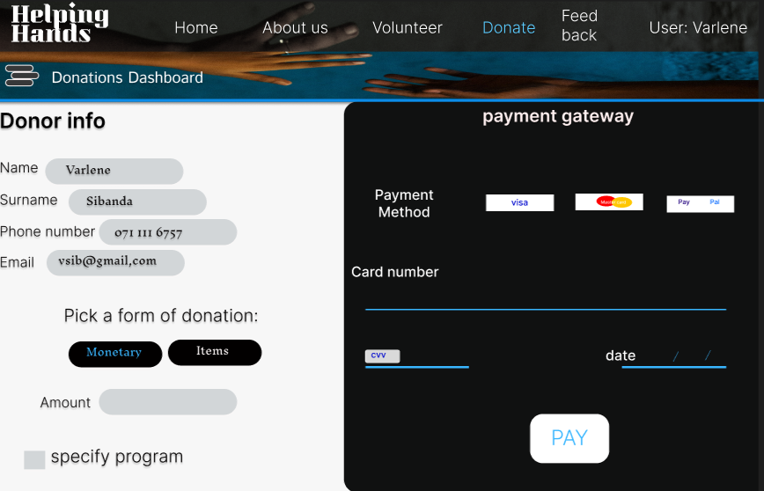

### 3. Donation Dashboard

User: Donors

The Donation Dashboard is tailored to individuals who contribute to Helping Hands, it includes a simple form for making new donations, where users can specify the type of donation (money or goods) and select causes to support. Donors can easily choose to contribute to specific programs, such as disaster relief, education, or community development, ensuring their contributions align with their values

The platform also integrates secure payment methods and downloadable receipts for tax purposes. Notifications provide updates on new campaigns or urgent needs, encouraging continued support. Notifications keep donors informed about new campaigns, urgent needs, or milestones achieved through their generosity, encouraging ongoing support.

By fostering trust and engagement, the Donation Dashboard enables donors to play an active and informed role in the Helping Hands mission, making the process efficient, secure, and rewarding.

Requirements Met:

* Enables donors to view, manage, and track their contributions.
* Provides tools for secure and transparent donations.

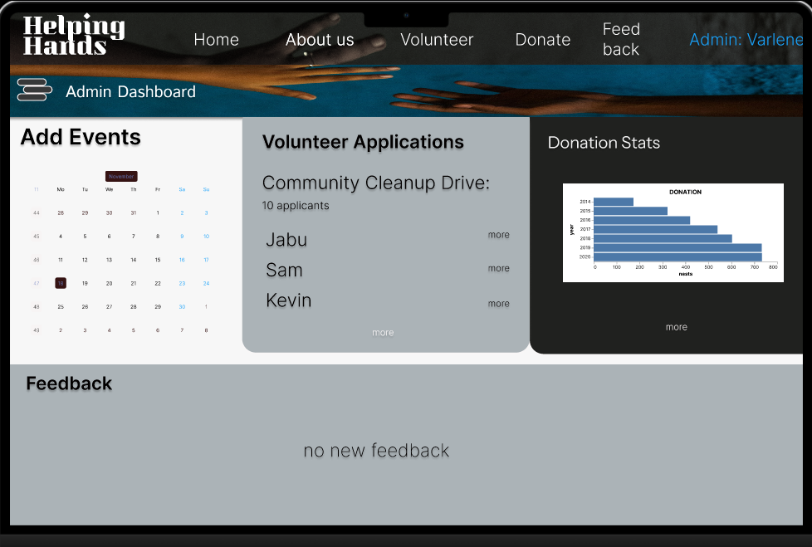

### 4. Admin Dashboard

User: Admins

The Admin Dashboard serves as the operational hub for Helping Hands. It is designed for administrators to manage the platform’s core functions, such as user accounts, event applications, and feedback analysis. Admins can approve or reject new volunteer registrations, and oversee event applications.

A comprehensive overview of platform activity is presented via summary cards and graphs, which display metrics like the number of active volunteers, donations received, and upcoming events. The dashboard also allows for bulk approvals or rejections of applications to streamline operations. For example, if a large number of volunteers apply for an event, the admin can review and approve them quickly.

Admins can also view and update, add, or delete events . The admin dashboard ensures that all areas of Helping Hands operate smoothly and efficiently.

Requirements Met:

* Facilitates efficient management of user accounts, donations, and events.
* Provides administrators with oversight and tools to coordinate platform activities effectively.

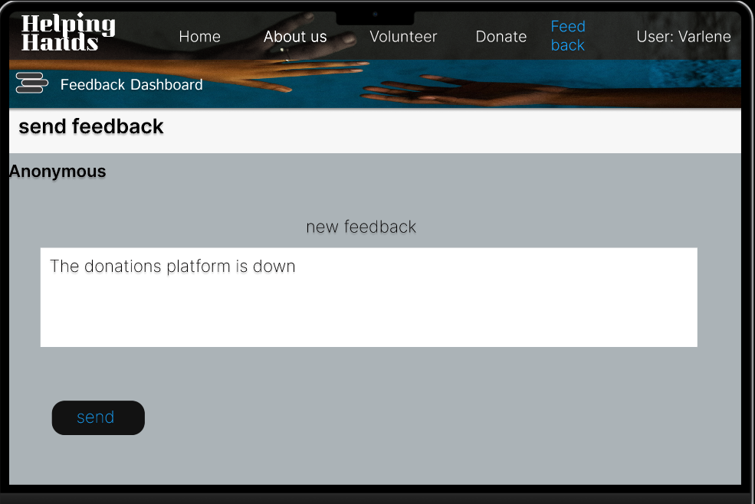

### 5. Feedback Dashboard

User: Volunteers and Donors

The Feedback Dashboard allows users to share their experiences with Helping Hands. Volunteers can leave comments about their participation in events, while donors can provide feedback on their contribution process. A structured form ensures users can easily submit their thoughts, or suggestions.

Admins can access the feedback through a secure interface, which categorizes responses based on themes like volunteer satisfaction or process improvement. This dashboard supports continuous improvement by giving the organization valuable insights into user experiences.

Notifications encourage users to leave feedback after events or donation campaigns. This feature helps Helping Hands maintain a strong relationship with its contributors by demonstrating their voices are valued.

Requirements Met:

* Enables transparent communication between users and administrators.
* Collects and categorizes feedback for organizational improvement.

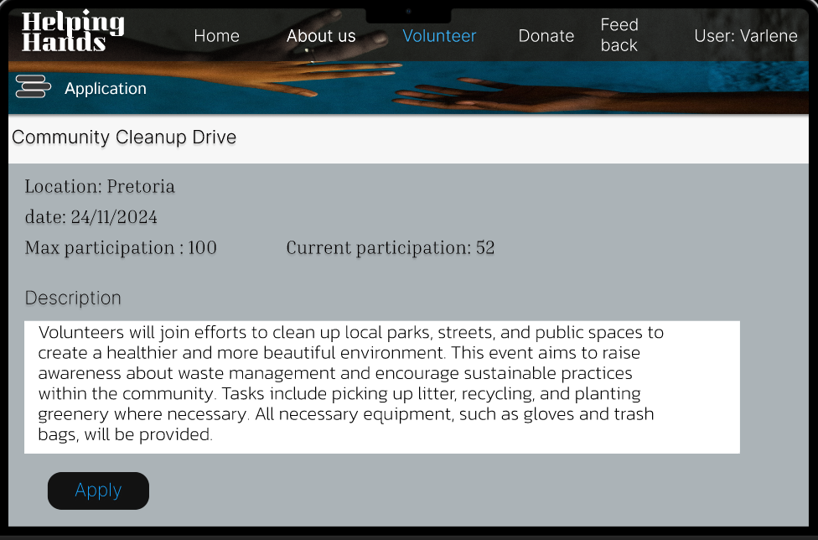

### 6. Event Application Page

User: Volunteers

The Event Application Page is the gateway for volunteers to sign up for specific initiatives. Users can browse through detailed descriptions of upcoming events, including event dates, locations, and required roles. For example, volunteers might apply for a food drive or a tutoring session by clicking on the respective event. The event card is displayed with all the information of the event.

Each event listing includes an “Apply” button, which redirects users to a form where they can confirm their availability and provide additional details if required. A search and filter option makes it easy to find events based on location, date, or area of interest.

This page simplifies the application process, ensuring volunteers can quickly find and commit to roles that align with their skills and availability.

Requirements Met:

* Provides volunteers with detailed event information.
* Simplifies the application process for participation in events.

### Self- Evaluation

The journey through this module has been both enriching and transformative, offering a deeper understanding of the software development lifecycle and the nuances of creating user-centric solutions. Working on the Helping Hands project has been a defining experience, requiring a balance between technical feasibility, design simplicity, and user accessibility. This project not only tested my technical abilities but also challenged me to think critically about user needs, scalability, and system efficiency.

Key Learnings:

1. Requirement Gathering:
2. Developing a Software Requirements Specification (SRS) document for Helping Hands deepened my ability to articulate functional and non-functional requirements clearly and systematically. Understanding the needs of different user groups—volunteers, donors, and administrators—was essential for ensuring the platform addressed diverse objectives.
3. Design and Prototyping:

Crafting the design for dashboards and interfaces helped me appreciate the importance of UI/UX principles. Creating tailored dashboards for each user type required me to consider usability, aesthetics, and accessibility simultaneously. This experience underscored the significance of iterative design processes and the role of feedback in refining solutions.

1. Scalability and Security:

Designing for a platform with features such as secure online donations, event management, and feedback analysis provided me with insights into scalable system architecture. I also learned how critical security is in building user trust, especially in handling sensitive data like payment details.

1. Agile Methodology:

The iterative and flexible approach of Agile allowed for continuous improvement of the Helping Hands platform. Frequent feedback and incremental progress helped ensure alignment with organizational goals while adapting to unforeseen challenges.

Challenges and Solutions:

* Balancing Simplicity and Functionality:

Designing multiple dashboards for distinct user groups was challenging. Striking a balance between simplicity for end-users and robust functionality for administrators required several iterations and thoughtful feedback incorporation.

* Technical Implementation Decisions:

While the theoretical design was straightforward, translating these into a scalable and maintainable architecture involved learning about microservices and modular design. This challenge enhanced my problem-solving skills and broadened my technical toolkit.

Personal Growth:

This project significantly enhanced my ability to manage complex tasks, prioritize user needs, and deliver solutions that are both functional and user-friendly. Collaborating with peers and iterating on feedback solidified my understanding of teamwork's importance in the software development process. Furthermore, my analytical and organizational skills were strengthened, preparing me for similar real-world scenarios.

Future Application:

I am eager to apply the lessons learned in this module to future projects. Whether designing user interfaces, creating scalable architectures, or managing requirements, I am confident these skills will enable me to contribute effectively to any team or organization.

This module has been instrumental in shaping my perspective on software engineering, particularly the importance of aligning technical solutions with user and organizational needs. I look forward to continuing this journey of learning and professional growth.

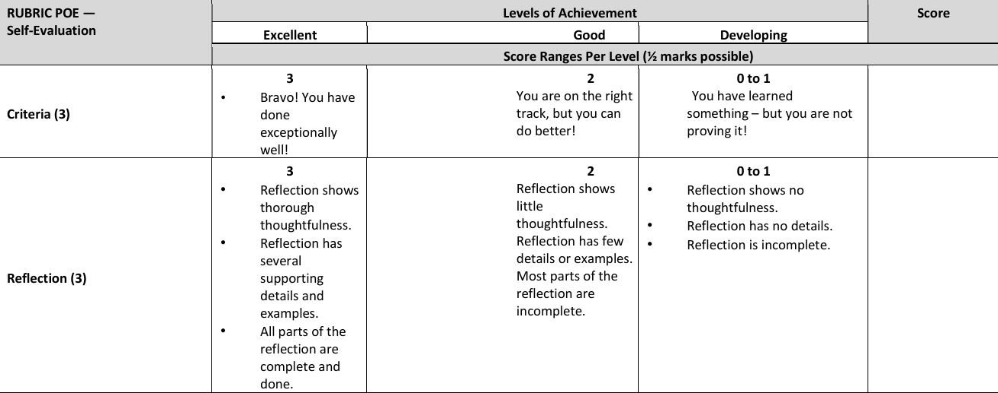

3

3

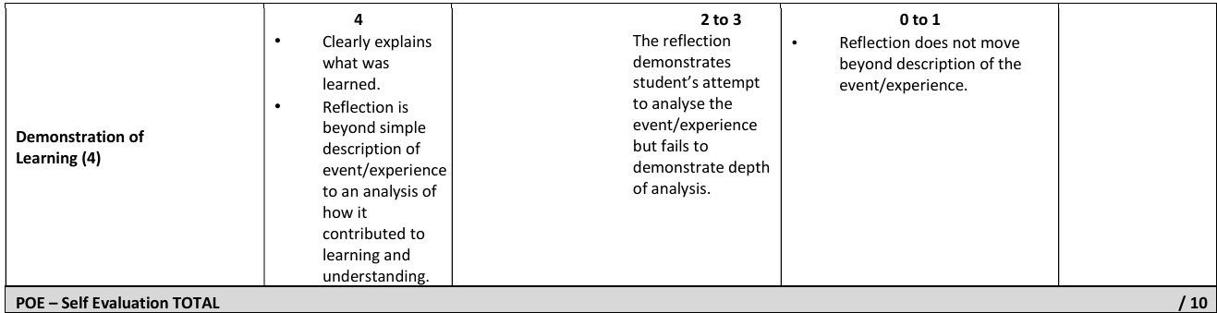

4

### Self-Reflection

The module provided an enriching experience, offering a deeper understanding of the software development lifecycle and the creation of user-centric solutions. Working on the Helping Hands project was transformative, balancing technical feasibility, design simplicity, and user accessibility. Developing the Software Requirements Specification (SRS) document helped refine my ability to gather and articulate functional and non-functional requirements. Designing dashboards for different user groups underscored the importance of UI/UX principles, iterative design, and feedback. I also gained insights into scalable system architecture and the critical role of security in handling sensitive data.

Using Agile methodology fostered continuous improvement and alignment with goals, while challenges such as balancing simplicity with functionality and implementing scalable architecture enhanced my technical skills. This project improved my ability to manage tasks, prioritize user needs, and work collaboratively, strengthening my analytical and organizational abilities. Looking ahead, I’m excited to apply these lessons to future projects, confident that the skills gained will enable me to contribute effectively in any software development team. This module has deepened my perspective on aligning technical solutions with user and organizational needs, shaping my future as a software engineer.